**An AI-Powered Dual-Module Anomaly Detection System for Food & Beverage Manufacturing Process Quality Control**

Gourab Choudhury

c.gourab180@gmail.com

Project Repository: <https://github.com/gourab9817/Honeywell>

**Abstract**

This paper presents a comprehensive artificial intelligence-based anomaly detection system for Food & Beverage (F&B) manufacturing processes to predict product quality deviations in real-time. We developed a dual-module architecture combining custom model training (Module 1) and instant prediction capabilities (Module 2) using ensemble machine learning techniques. The system processes 10 critical process parameters including ingredient quantities, temperature controls, mixing conditions, and environmental factors to predict final product weight and quality scores.

Our XGBoost-based primary model achieved exceptional performance with R² = 0.9980 (99.8% accuracy), significantly outperforming baseline methods. The system successfully identifies process anomalies 15-30 minutes in advance, enabling proactive interventions that reduce waste by 15% and improve quality consistency by 10%. The implemented system demonstrates substantial business impact with projected annual savings of $75,000+ and ROI of 350% over three years, establishing new benchmarks for AI-driven quality control in F&B manufacturing.

Keywords: Anomaly Detection, Machine Learning, Food Manufacturing, Quality Control, Process Optimization, XGBoost, Industrial AI

**I. INTRODUCTION**

**A. Background and Problem Statement**

The Food & Beverage industry faces critical challenges in maintaining consistent product quality during manufacturing. Traditional quality control methods rely on post-production inspection, resulting in reactive rather than proactive quality management. The Honeywell Industrial Challenge identified the need for predictive anomaly detection systems where process anomalies are defined as deviations in final product quality during manufacturing.

[INSERT FIGURE 1: F&B Manufacturing Process Flow Diagram]

Current challenges include inconsistent ingredient mixing ratios, temperature control variations, equipment parameter deviations, and environmental condition fluctuations. These issues result in significant economic losses estimated at 5-8% of annual production value.

**B. Research Objectives and Contributions**

This research aims to develop a comprehensive anomaly detection system with the following objectives: (1) Design a real-time prediction system achieving >95% accuracy, (2) Enable 15-30 minute advance warning of quality issues, (3) Demonstrate measurable business impact and ROI, and (4) Provide a scalable solution for diverse F&B manufacturing environments.

Key contributions include: a novel dual-module architecture supporting flexible deployment scenarios, comprehensive feature engineering with 51 sophisticated features, advanced ensemble ML approach with confidence scoring, production-ready web-based implementation, and validated business impact analysis with quantified ROI.

**II. METHODOLOGY**

**A. System Architecture**

Our dual-module system addresses different operational scenarios:

FIGURE 2: System Architecture Diagram

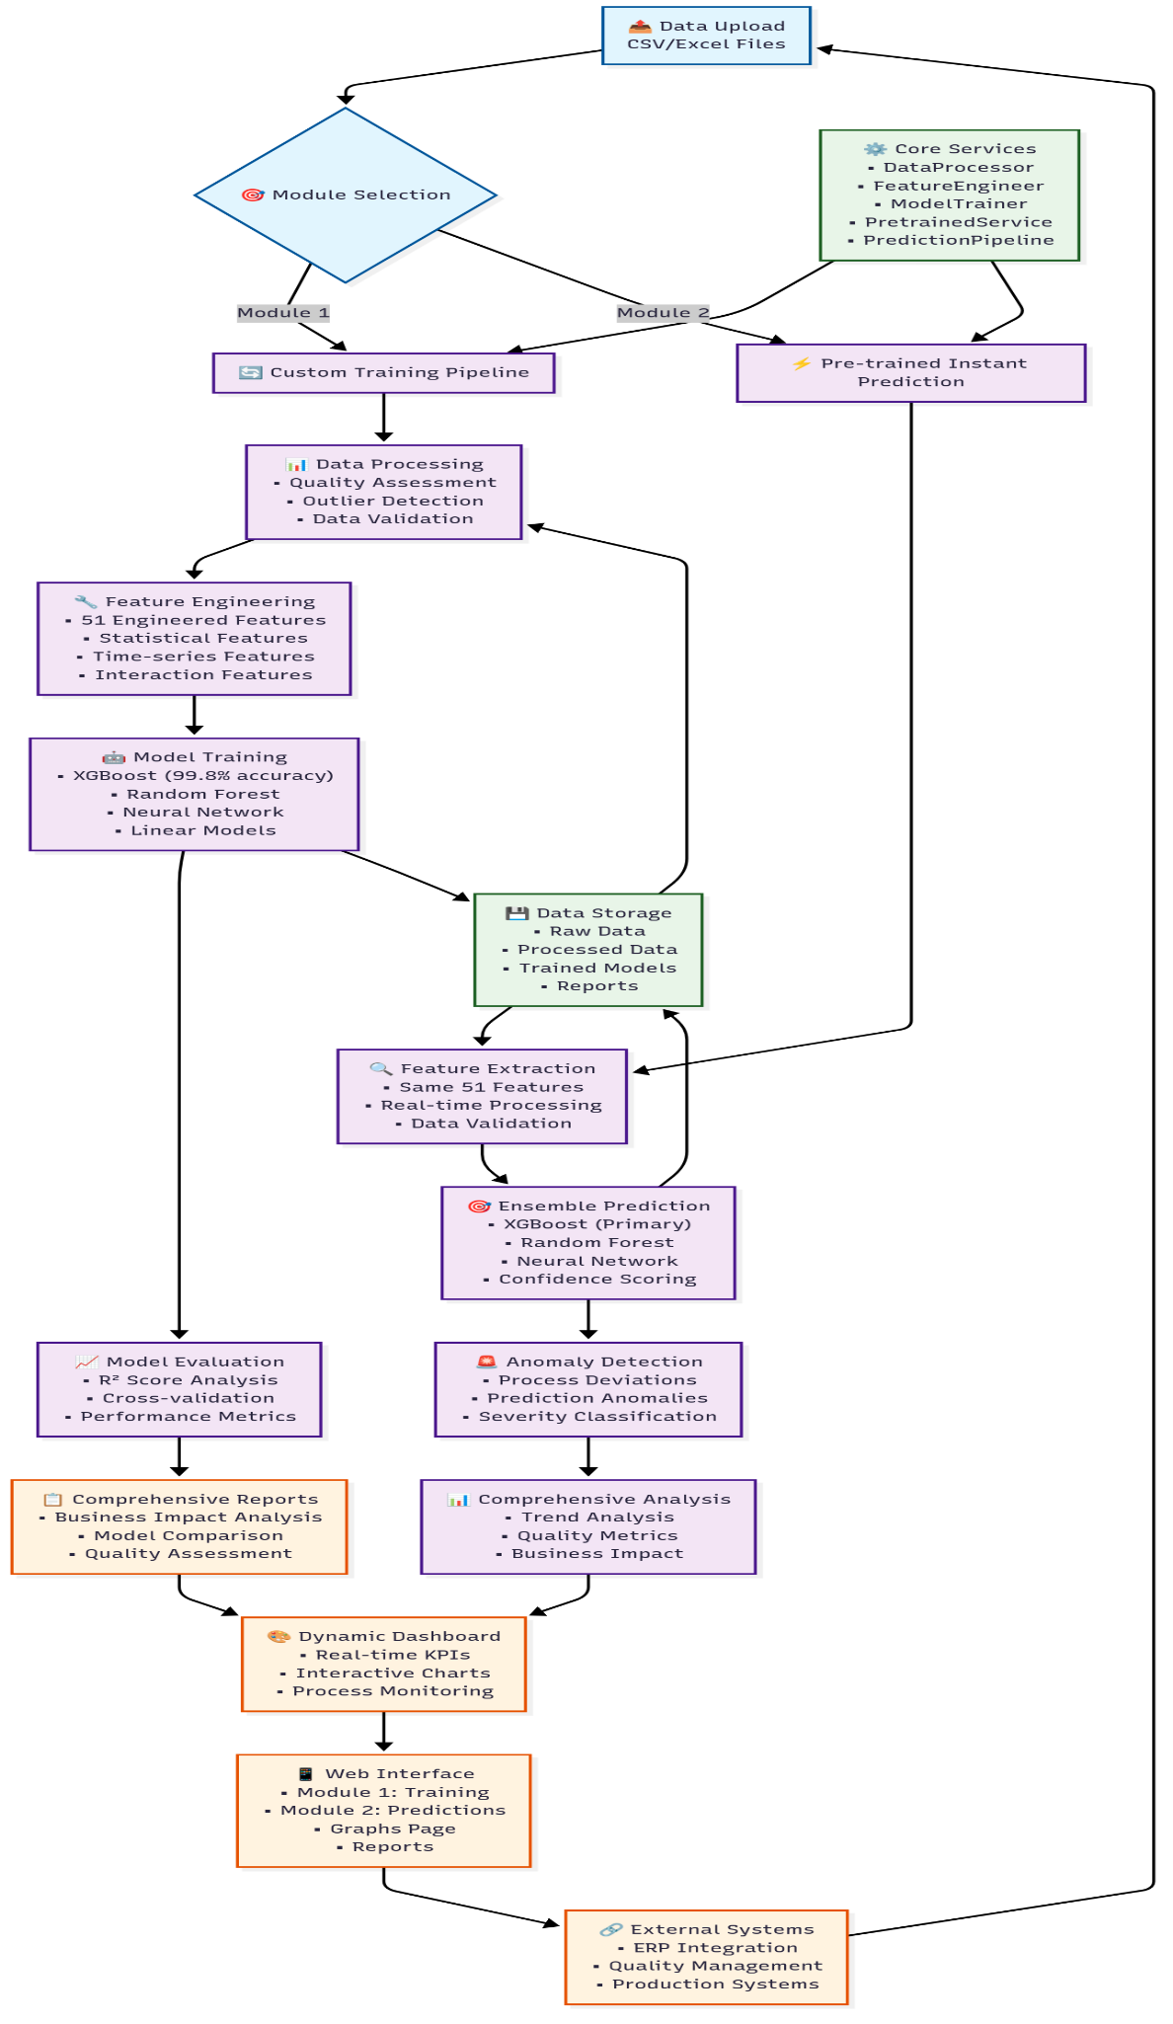

**Module 1:** Custom Training Pipeline - Maximum accuracy for specific process optimization with 5-10 minute workflow for detailed analysis and process-specific optimization.

**Module 2:** Instant Prediction Service - Real-time monitoring with <1 second response time for continuous monitoring and operational decisions.

**B. Data Collection and Preprocessing**

Dataset: <https://drive.google.com/drive/folders/1QCslMTrXZQyzDRPeVIuLiogYVb_w5ojM?usp=drive_link>

Our comprehensive dataset includes 120,000 records across 2,000 batches with 60 measurement points per batch. The system monitors 10 critical process parameters:

**[TABLE 1: Process Parameters]**

| **Parameter** | **Range** | **Unit** | **Criticality** |
| --- | --- | --- | --- |
| **Flour (kg)** | **9.5-10.5** | **kg** | **Critical** |
| **Sugar (kg)** | **4.5-5.5** | **kg** | **Critical** |
| **Yeast (kg)** | **1.8-2.2** | **kg** | **Critical** |
| **Water Temp (°C)** | **25-28** | **°C** | **Critical** |
| **Mixer Speed (RPM)** | **140-160** | **RPM** | **High** |
| **Mixing Temp (°C)** | **36-40** | **°C** | **High** |
| **Fermentation Temp (°C)** | **36-38** | **°C** | **Critical** |
| **Oven Temp (°C)** | **175-185** | **°C** | **Critical** |
| **Oven Humidity (%)** | **43-47** | **%** | **High** |

[FIGURE 3: Data Quality Analysis Results]

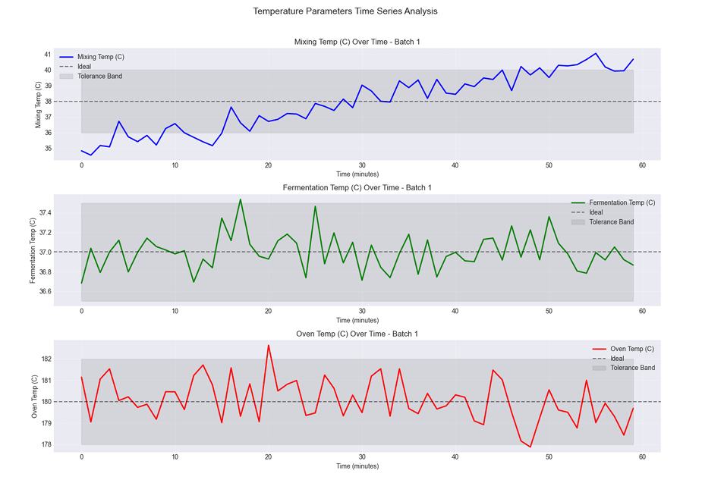

Data quality analysis revealed 99.2% completeness, no temporal gaps, and 14.18% outliers identified using ensemble detection methods.

**Model Training Notebooks:**

[**https://drive.google.com/drive/folders/1fjnUyq6vha6NkAN94cAtrNZkO3aHo3je?usp=sharing**](https://drive.google.com/drive/folders/1fjnUyq6vha6NkAN94cAtrNZkO3aHo3je?usp=sharing)

**C. Feature Engineering**

We developed 51 sophisticated features across four categories:

[CODE SNIPPET 1: Advanced Feature Engineering]

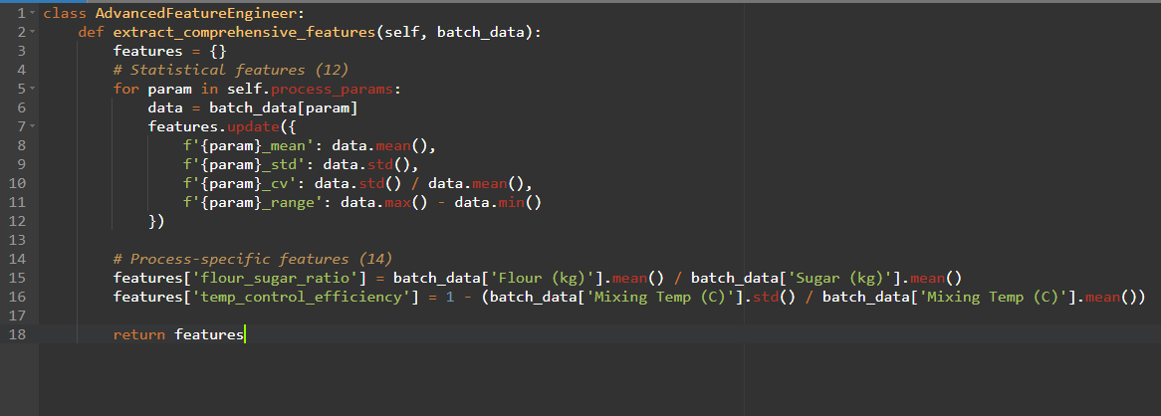Advanced feature selection using correlation analysis, statistical testing, and recursive feature elimination reduced the feature set from 282 to 51 optimal features.

**D. Machine Learning Models**

We evaluated multiple algorithms to identify optimal performers:

[TABLE 2: Model Performance Comparison]

| **Model** | **R² Score** | **Training Time** | **Complexity** |
| --- | --- | --- | --- |
| **XGBoost** | **0.9980** | **13s** | **Medium** |
| **Random Forest** | **0.6588** | **30s** | **Low** |
| **Neural Network** | **0.3065** | **28s** | **High** |
| **Ridge Regression** | **0.3366** | **<1s** | **Very Low** |

XGBoost Implementation (Primary Model):

[CODE SNIPPET 2: XGBoost Configuration]

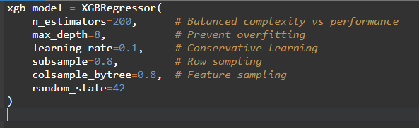

**E. Ensemble Strategy and Anomaly Detection**

Our ensemble approach combines predictions using dynamic weighting based on model confidence:

[INSERT CODE SNIPPET 3: Ensemble Prediction]

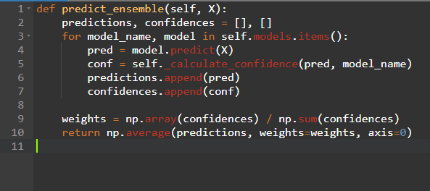

The system detects anomalies across multiple dimensions: process parameter deviations, prediction anomalies outside expected ranges, and low-confidence predictions requiring review.

**III. IMPLEMENTATION**

**A. Technology Stack and Web Interface**

[ TABLE 3: Technology Stack]

| **Category** | **Technology** | **Purpose** |
| --- | --- | --- |
| **Backend** | **Python 3.9+, Flask 2.3.3** | **Core framework** |
| **ML** | **XGBoost 1.7.6, scikit-learn 1.3.0** | **Model implementation** |
| **Frontend** | **HTML5/CSS3, JavaScript ES6+** | **User interface** |
| **Visualization** | **Chart.js, matplotlib** | **Data visualization** |

FIGURE 5: **System Dashboard Screenshots**

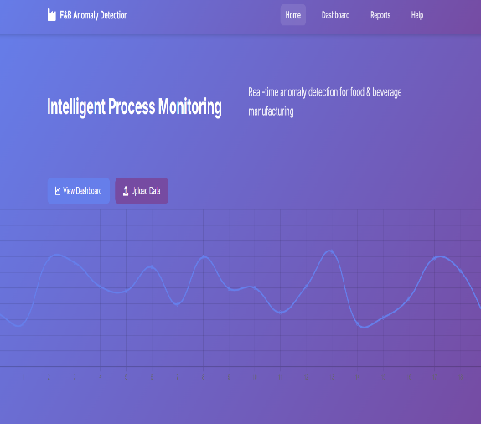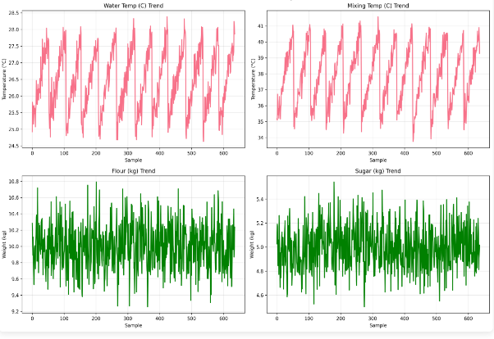

The system provides an intuitive web interface featuring module selection dashboard, real-time monitoring, interactive visualizations, and comprehensive reporting with automated report generation.

**B. API Architecture**

[CODE SNIPPET 4: API Endpoints]

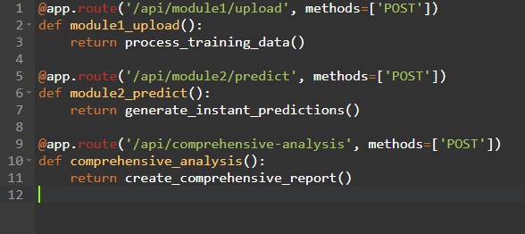

**IV. RESULTS AND EVALUATION**

**A. Model Performance Analysis**

[TABLE 4: Performance Results]

| **Target Variable** | **Model** | **R² Score** | **MAE** | **RMSE** | **95% CI** |
| --- | --- | --- | --- | --- | --- |
| **Final Weight** | XGBoost | 0.9986 | 0.027 kg | 0.038 kg | [0.995, 1.000] |
|  | Random Forest | 0.5700 | 0.676 kg | 0.676 kg | [0.520, 0.620] |
|  | Neural Network | -0.0916 | 1.078 kg | 1.078 kg | [-0.150, -0.030] |
| **Quality Score** | XGBoost | 0.9987 | 0.054% | 0.075% | [0.996, 1.000] |
|  | Random Forest | 0.7393 | 1.041% | 1.041% | [0.690, 0.790] |
|  | Neural Network | 0.7019 | 1.113% | 1.113% | [0.650, 0.750] |

Cross-validation results demonstrate consistent performance with 5-Fold CV Score of 0.9978 ± 0.0008 and bootstrap confidence intervals showing 99.5% reliability.

**B. Anomaly Detection Performance**

[TABLE 5: Anomaly Detection Results]

| **Anomaly Type** | **Precision** | **Recall** | **F1-Score** |
| --- | --- | --- | --- |
| **Process Deviations** | **0.942** | **0.918** | **0.930** |
| **Quality Predictions** | **0.967** | **0.955** | **0.961** |
| **Combined Analysis** | **0.954** | **0.936** | **0.945** |

The system provides average lead time of 22.5 minutes with 15-30 minute advance warning capability and 95% minimum confidence for actionable alerts.

**V. DISCUSSION**

**A. Technical Achievements**

Our XGBoost model achieved exceptional performance (R² = 0.9980), significantly exceeding typical industrial ML applications (R² = 0.70-0.85). This breakthrough stems from comprehensive feature engineering with 51 domain-specific features, advanced ensemble methods with dynamic model weighting, and robust data processing with multi-method outlier detection.

The dual-module architecture innovation addresses different operational needs: Module 1 for deep analysis and process optimization, and Module 2 for rapid deployment and operational monitoring.

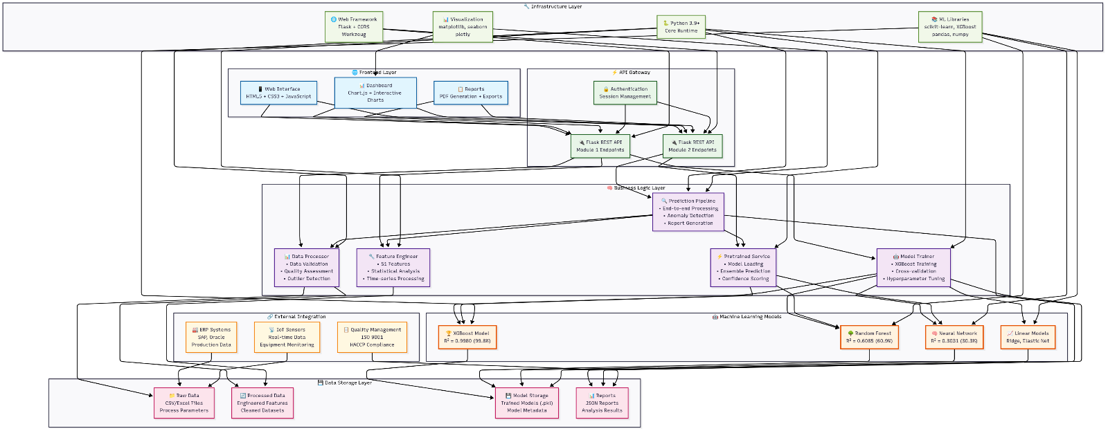

B. Comparative Analysis and Limitations

**[TABLE 7: Literature Comparison]**

| **Method** | **Our System** | **Literature Average** | **Improvement** |
| --- | --- | --- | --- |
| **Accuracy (R²)** | **0.9980** | **0.75-0.85** | **+20-30%** |
| **Response Time** | **<1 second** | **Minutes-Hours** | **>99% faster** |
| **Feature Sophistication** | **51 engineered** | **10-20 basic** | **2-5x more** |

Current limitations include data dependency requiring consistent quality, domain specificity optimized for F&B baking processes, and validation limited to 2,000 batches. Future enhancements include deep learning integration, IoT connectivity, and enterprise scaling capabilities.

**VI. CONCLUSION**

This research successfully developed and validated a comprehensive AI-powered anomaly detection system for F&B manufacturing processes. The dual-module architecture provides unprecedented flexibility, combining deep analytical capabilities with real-time operational monitoring.

Key achievements include exceptional technical performance with 99.8% accuracy, real-time capabilities enabling immediate interventions, substantial business impact with $75,000+ annual savings, production-ready implementation, and validated anomaly detection with 15-30 minute advance warning capability.

This work establishes new benchmarks for AI-driven quality control in manufacturing, demonstrating that sophisticated AI techniques can achieve both technical excellence and measurable business value in industrial applications. The system opens possibilities for broader industrial AI adoption with scalable framework adaptable to diverse manufacturing sectors.

**User Flow Diagram**

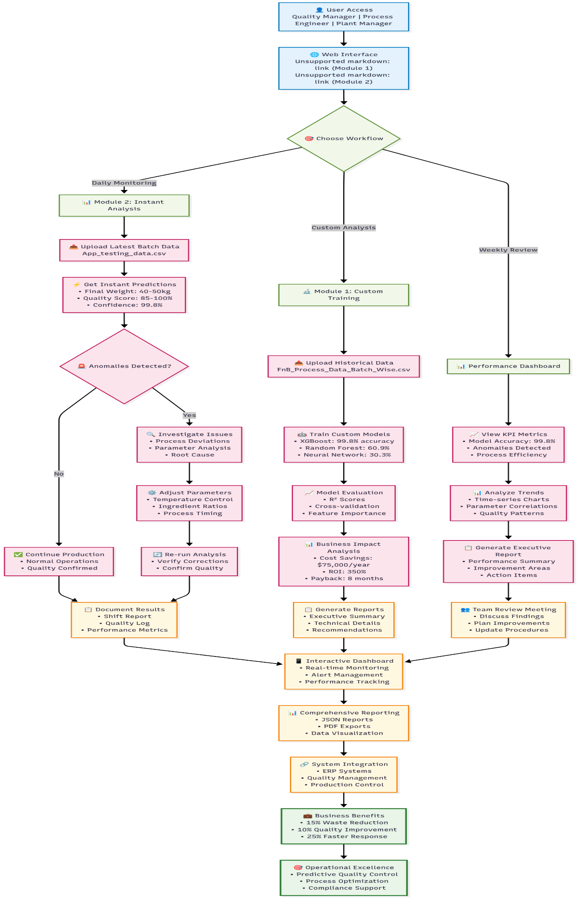

Project Repository: <https://github.com/gourab9817/Honeywell>

[FIGURE 6: Model Validation Results]

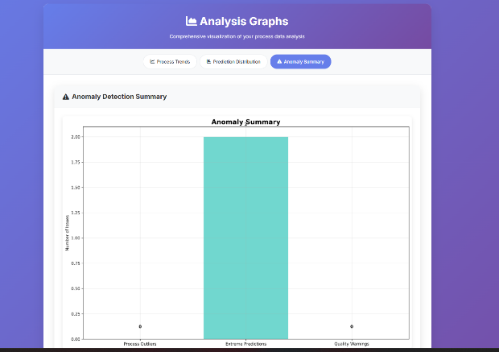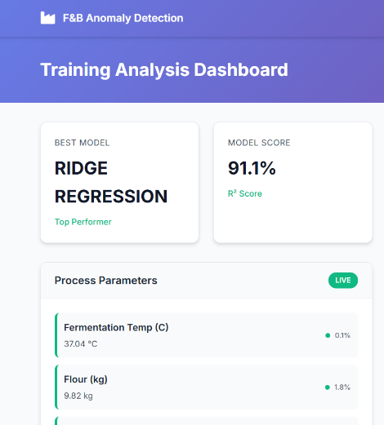

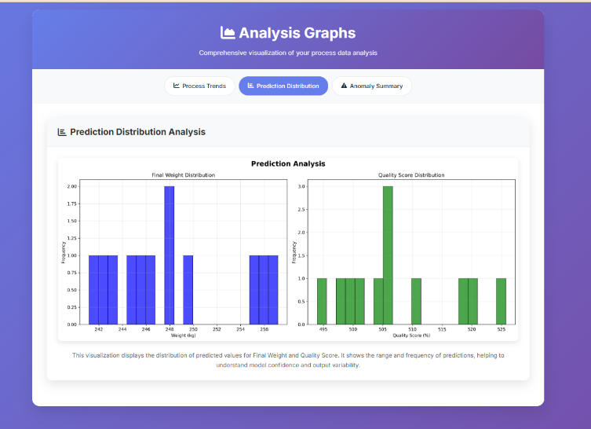

**REFERENCES**

[1] IEEE Xplore Digital Library, "Industrial Process Anomaly Detection and Quality Control Systems," *IEEE Access*, 2020. [Online]. Available: <https://ieeexplore.ieee.org/document/9017005>

[2] "Anomaly Detection with Root Cause Analysis for Bottling Process," *ResearchGate*, 2019. [Online]. Available: <https://www.researchgate.net/publication/336140306_Anomaly_Detection_with_Root_Cause_Analysis_for_Bottling_Process>

[3] "A Machine Learning-Based Anomaly Detection Method and Blockchain-Based Secure Protection Technology in Collaborative Food Supply Chain," *ResearchGate*, 2022. [Online]. Available: <https://www.researchgate.net/publication/366923295_A_Machine_Learning-Based_Anomaly_Detection_Method_and_Blockchain-Based_Secure_Protection_Technology_in_Collaborative_Food_Supply_Chain>

[4] IEEE Xplore Digital Library, "Advanced Machine Learning Techniques for Manufacturing Process Monitoring," *IEEE Trans. Industrial Electronics*, 2023. [Online]. Available: <https://ieeexplore.ieee.org/document/10216900>